User Account Management

User Account Management involves several features such as password recovery, account recovery, user registration, locking user accounts and password policies, etc. In this tutorial, we are going to try functionalities related to identity management in WSO2 Identity Server.

WSO2 IS Configurations

Configure the email server
- Configure the email server to send emails by following the below steps.
  - Open the deployment.toml file in the <IS_HOME>/repository/conf path.
  - Specify values for the from_address, username, and password parameters in the [output_adapter.email] section as shown in the extract below:
[output_adapter.email]
from_address="<email>"
username="<email>"
password="<password>"
hostname="smtp.gmail.com"
port=587
enable_start_tls=true
enable_authentication=true

(if you are using a gmail account as the sender, create an App password and use that as the password. If your password contains invalid characters such as “>” , “<” and “&”, enter the password as "<![CDATA[xxxx]]>")
- Navigate to <IS_HOME>/bin and start the server by executing either of the following commands.
Linux --> sh wso2server.sh
Windows --> wso2server.bat
- Log in to the Console App, and enter admin as both the username and the password.

Enable email invitations for user password setup
- On the WSO2 Identity Server Console, go to Flows > Invited User Registration.
- Toggle the Enable switch in the top-right corner to enable the invited user registration flow.
- Once the flow is enabled, administrators can invite users by email to set their own password.

Create a user
- Expand the User Management menu item, click on Users.
- On the Users page, click Add User and select Single User from the dropdown.
- In the opened up wizard,
  - Keep Primary as the user store.
  - Add the below configuration to the respective fields.
    - Username: tommy
    - Email: tommy@wso2.com
    - First Name: Tommy
    - Last Name: Dave
- Select Invite the user to set their own password option.
- Select Invite Via Email.
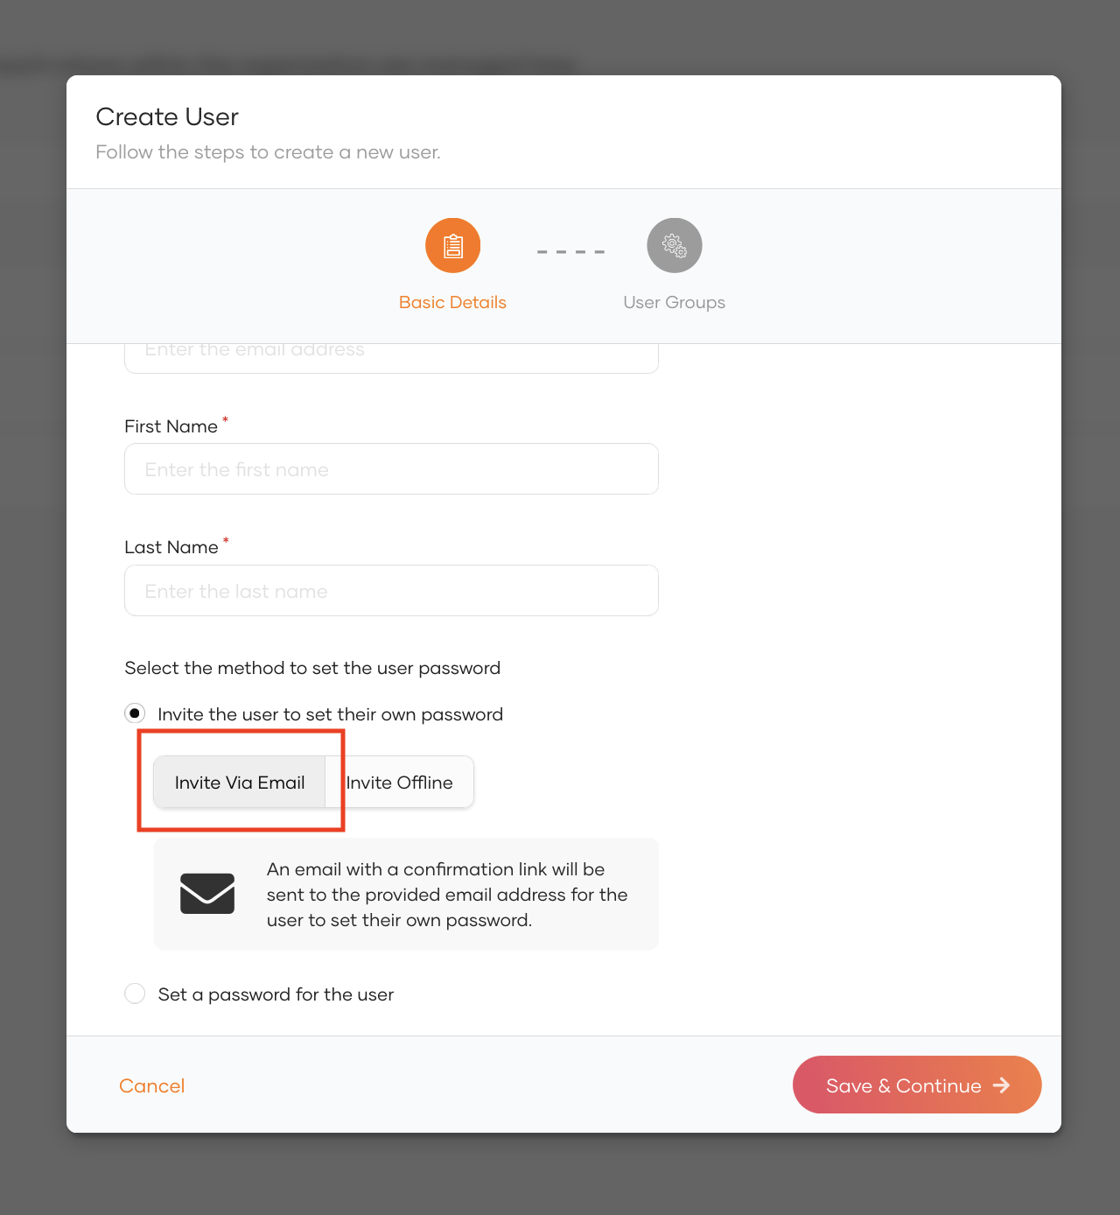
- Click Next.
- Skip group selection and Click Save & Continue.
- The user will receive an email to tommy@wso2.com with an invitation link to set the password.
- Open the Invitation link received.
- Add a password and confirm it.
  - Ex: Tommy@123

Password Recovery

Introduction:
In this section we will configure Email based password recovery option.

Setting up
- In the WSO2 Identity Server Console, go to Flows > Password Recovery.
- Toggle the switch to enable password recovery option to allow users to recover their passwords.
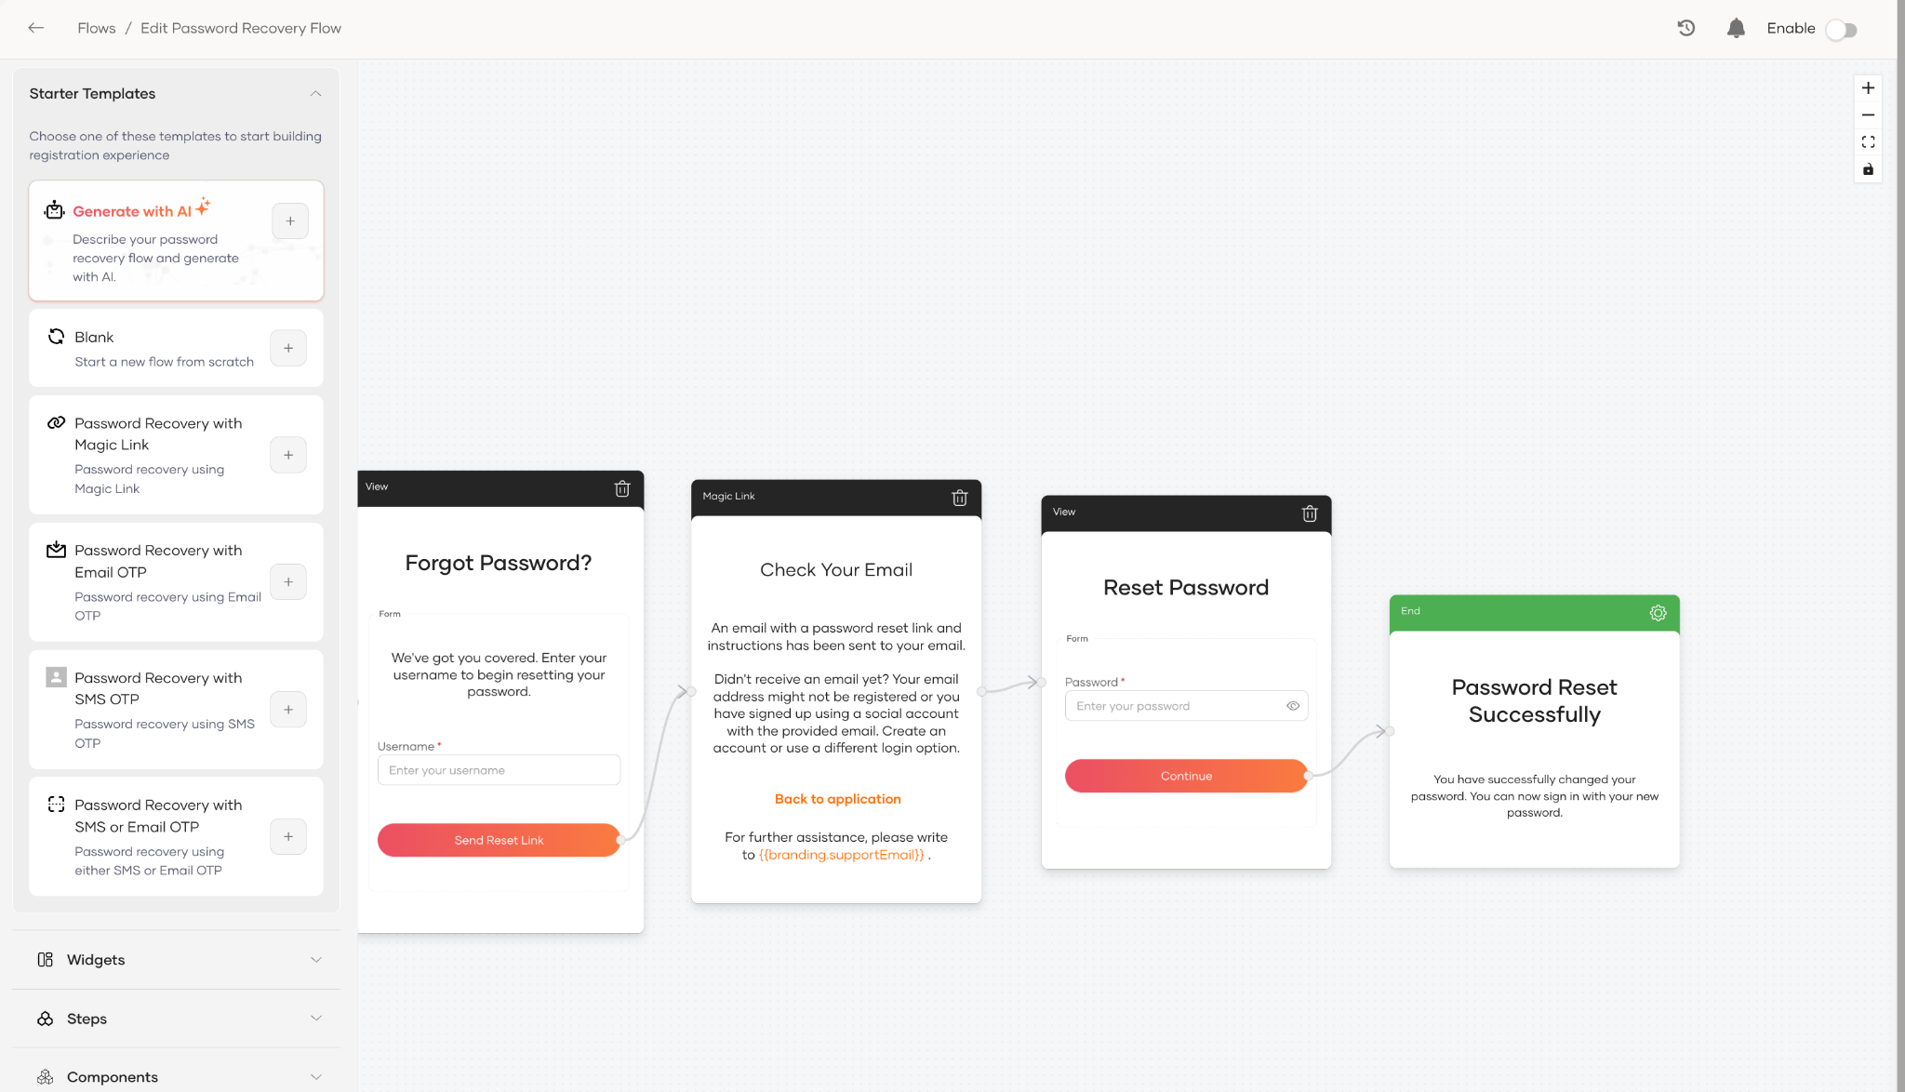

Try It
- Go to My Account.
- On the login page, click password in Forgot username or password?
- Enter the username tommy.
- Click Send Reset Link.
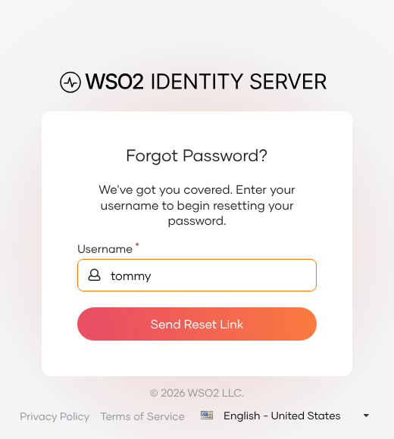
- An email notification is sent to the user's email address. Click on the Reset Password button in the email.
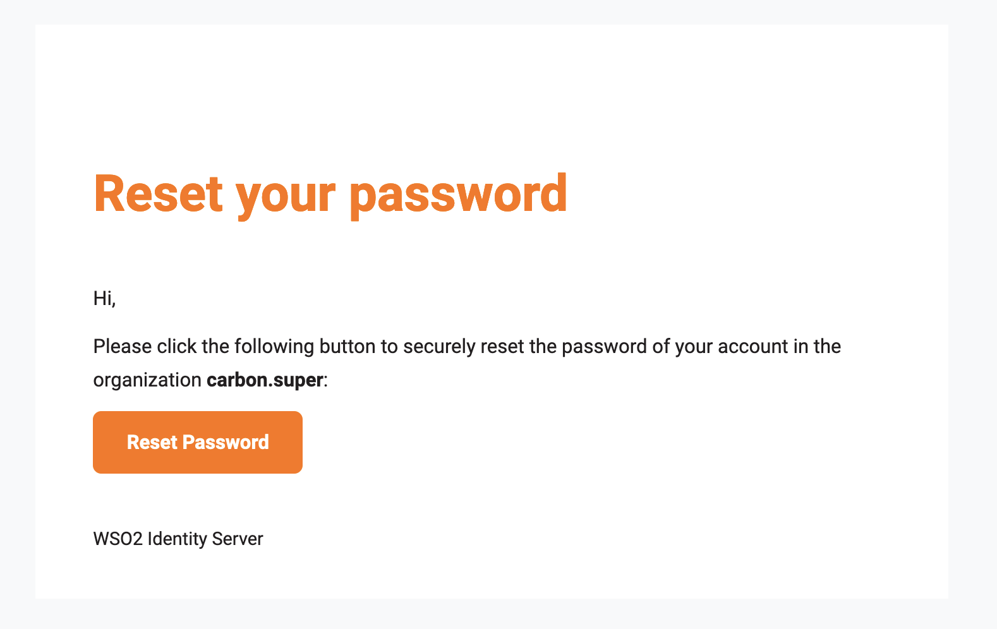
- Enter a new password and click Submit.

Username Recovery

Introduction:
In this section we will configure email based username recovery.

Setting up:
- In the WSO2 Identity Server Console, go to Login & Registration > Account Recovery > Username Recovery.
- Under Recovery Option Selection, select Enable email based recovery and click Update.
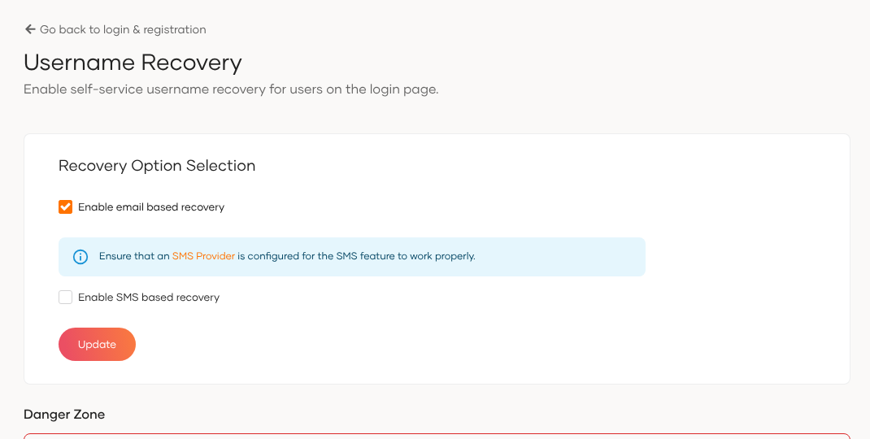

Try It:
- Go to My Account.
- On the login page, click username in Forgot username or password?
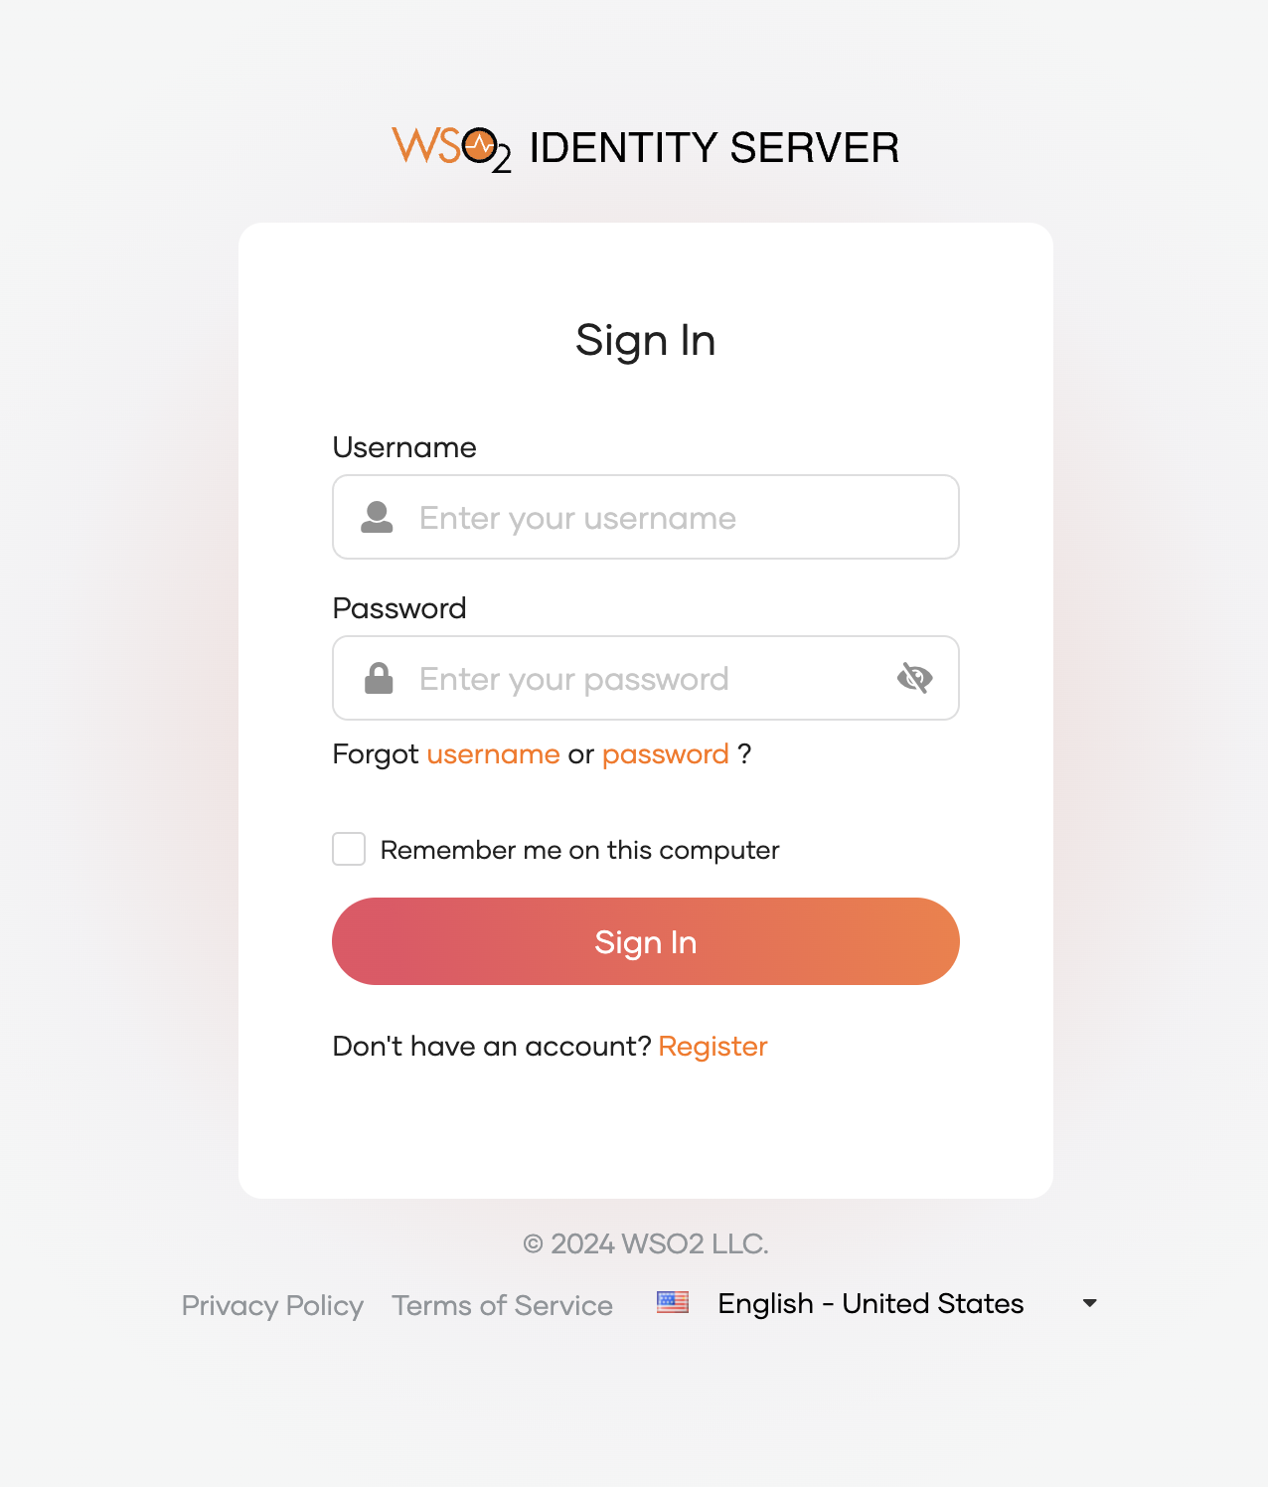
- Enter all the required fields and click Submit.
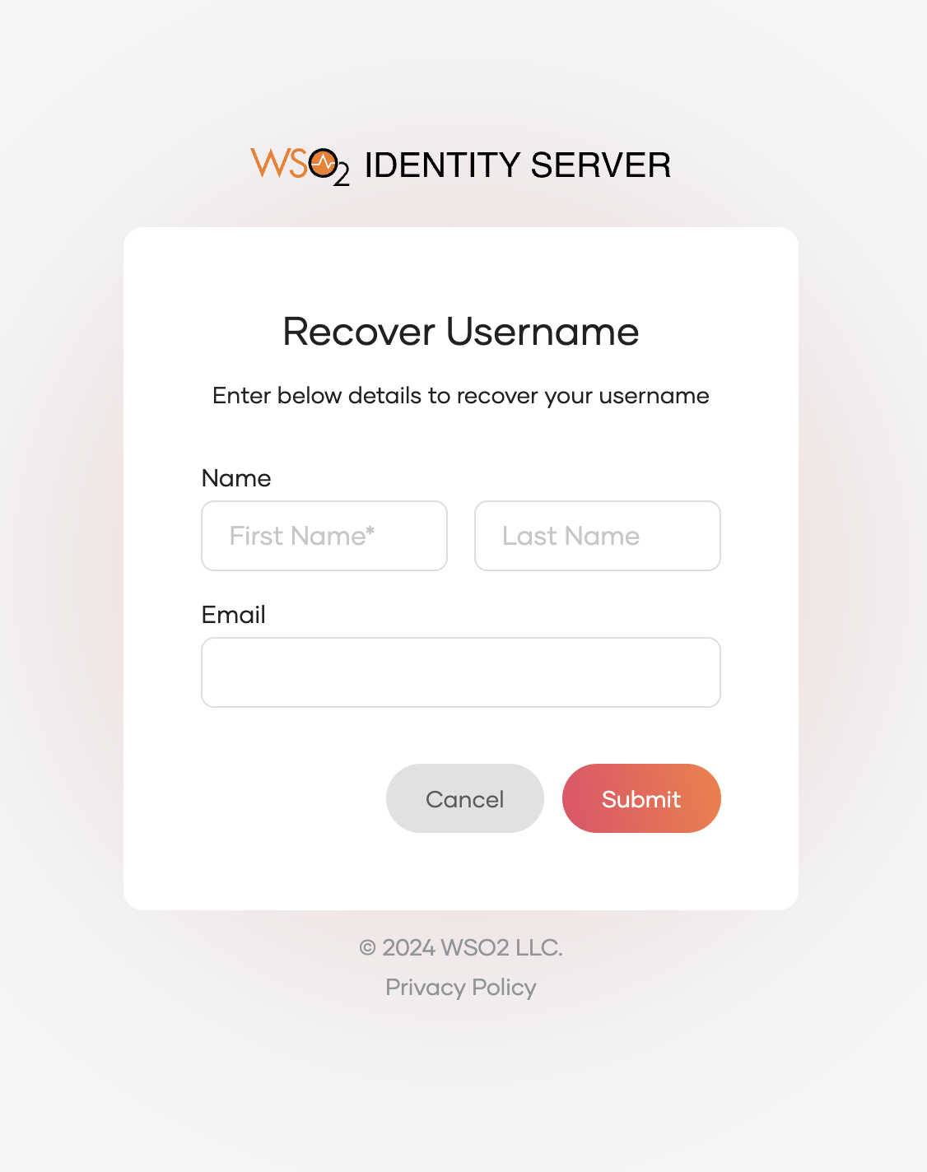
- An email notification will be sent to the user's email address with the recovered username.
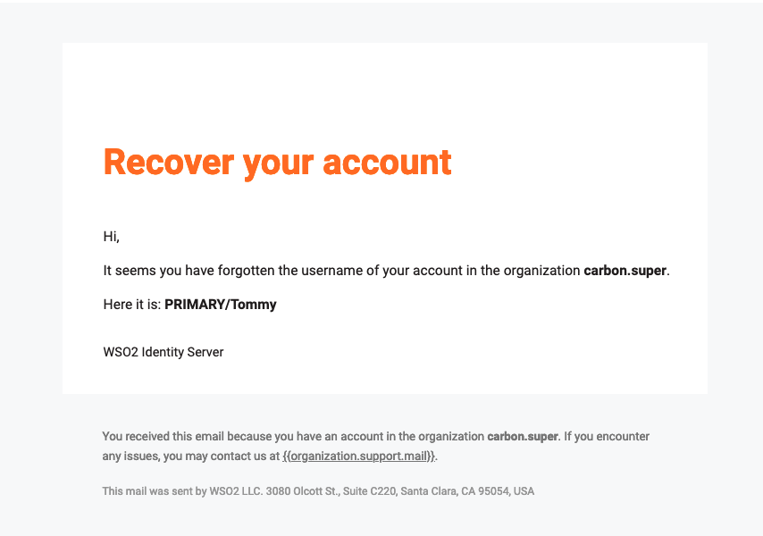

Account Locking

Introduction
The account locking feature is used to temporarily block a user from logging in. Account locking can be done by an administrative user or it can be configured to automatically lock upon multiple failed login attempts.

Setting up:

- To show more specific error messages on the login page, the following property can be configured in the deployment.toml file in <IS_HOME>/repository/conf path.
[authentication.authenticator.basic.parameters]
showAuthFailureReason=true
showAuthFailureReasonOnLoginPage=true

- Restart the server.

Account Locking by an administrator

Setting up:
- On the WSO2 Identity Server Console, expand the User Management menu item, click on Users.
- Select the user tommy.
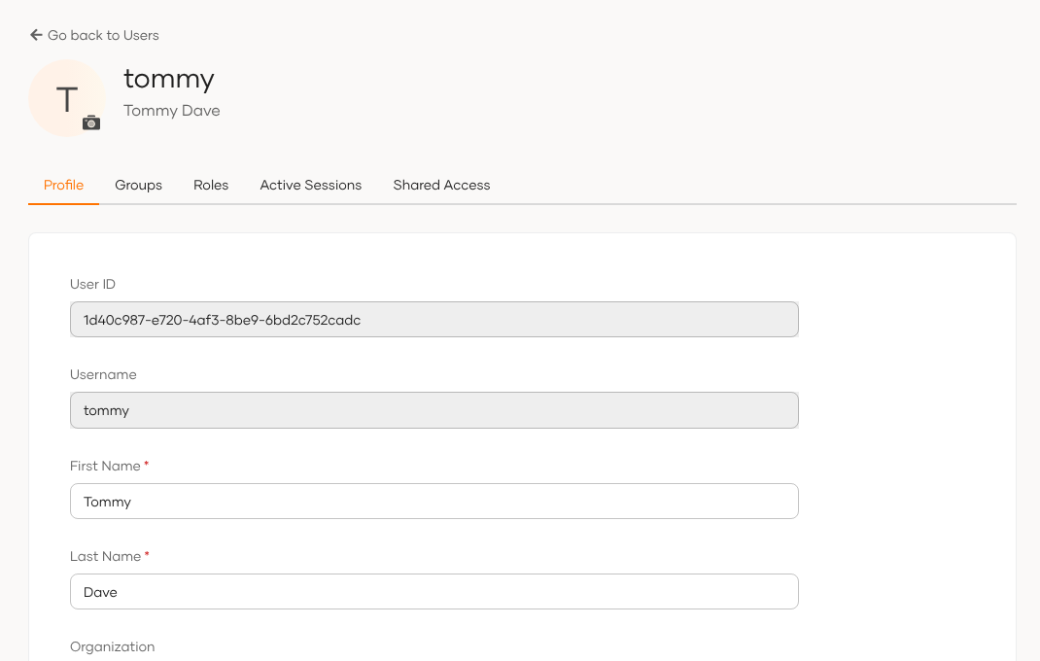
- Toggle the button on Lock user option at the bottom of the page.
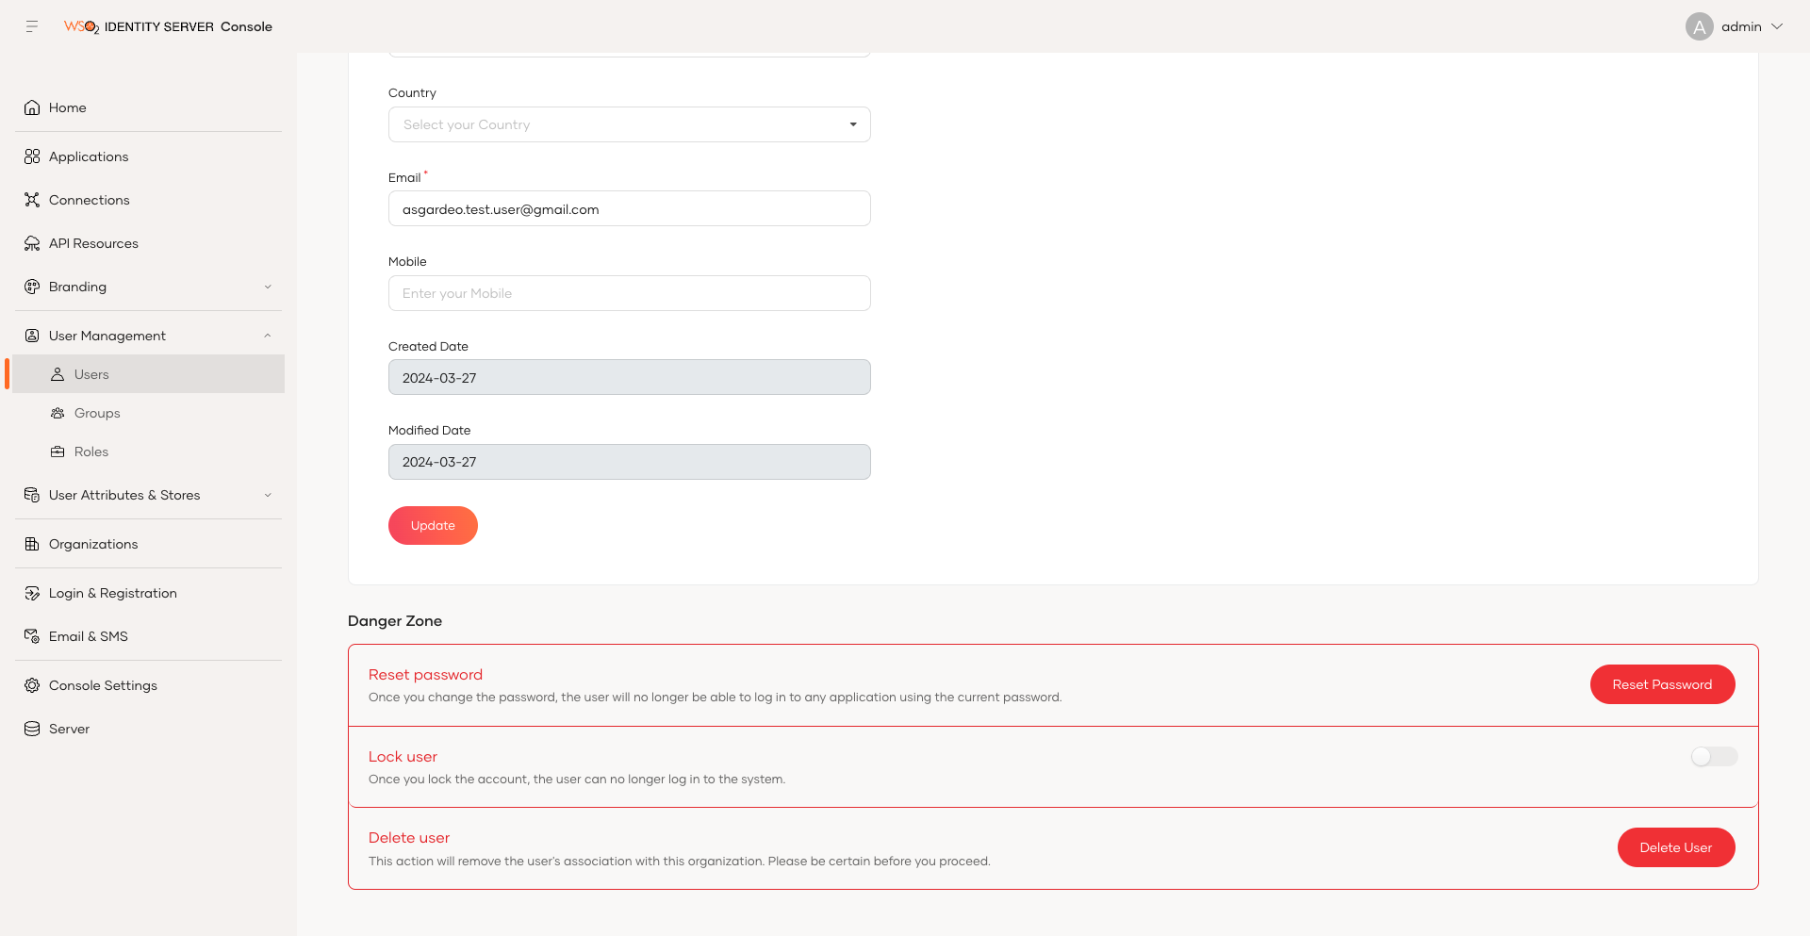
- Check the Please confirm your action check box in the pop up.
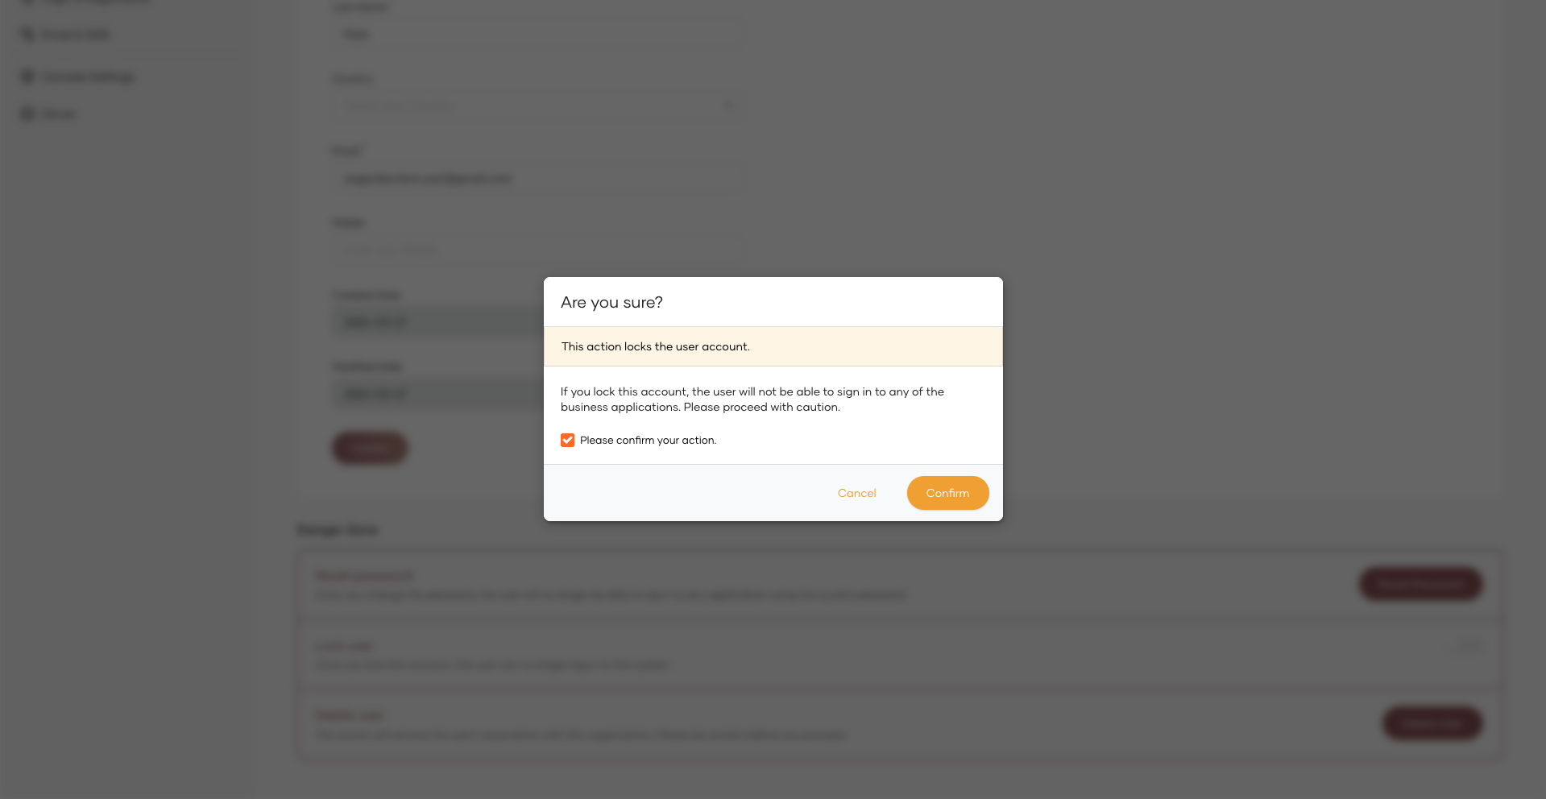

Try It:
- Go to My Account, and try to login as the user you locked.
- Now the login attempt will fail.
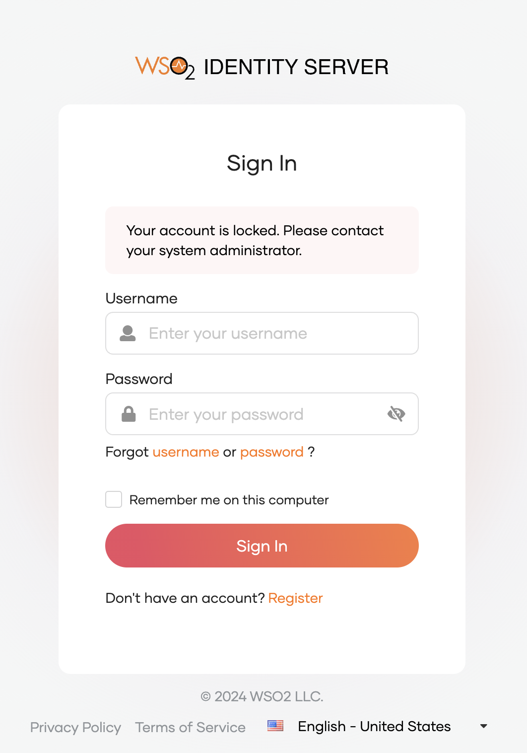
- An email notification will be sent to the user's email address mentioning the account has been locked.

Account Locking based on failed login attempts

Setting up:
- In the WSO2 Identity Server Console, go to Login & Registration > Login Security > Login Attempts
- Toggle the switch to enable lock user accounts on failed attempts.
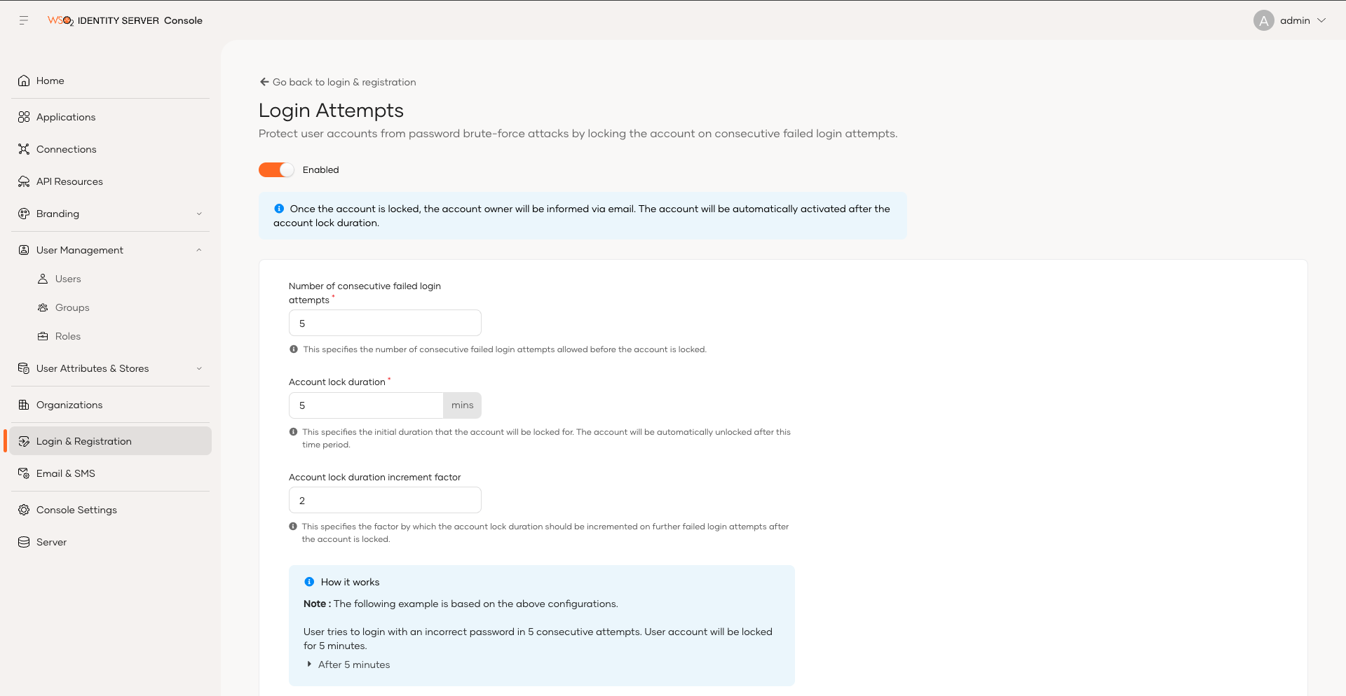
- Specify Maximum failed login attempts as follows.
Maximum failed login attempts: 3
- Click Update.

Try It:
- Go to My Account and try to log in as tommy with a wrong password 3 times. On the third attempt the login page shows that the account is temporarily locked.
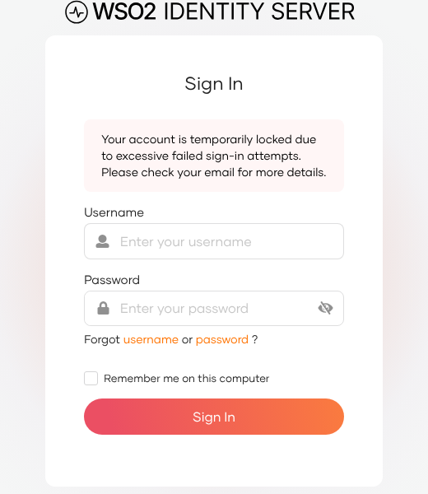
- An email that informs about the account locking is sent to the user's email address.
- Wait for 5 minutes and try to log in again with the correct credentials. The My Account home screen appears.

Password Policies
Password Policies are some set of rules that enhance the users to use strong passwords. WSO2 Identity server helps you to customize password patterns so as to enforce stronger password policies.

Password Input Validation

Introduction
Password input validation involves checking the validity of passwords entered by users against certain criteria or rules in real-time. Using this feature, organizations can enforce the users to input passwords that meet the required length, complexity, and other specified criteria for passwords.

Setting up:
- In the WSO2 Identity Server Console, go to Login & Registration > Login Security > Password Validation.
- Adjust password policies accordingly. Change the following fields.
Password Input Validation
- Must be between 5 and 10 characters
- Must contain at least 2 numbers (0-9).

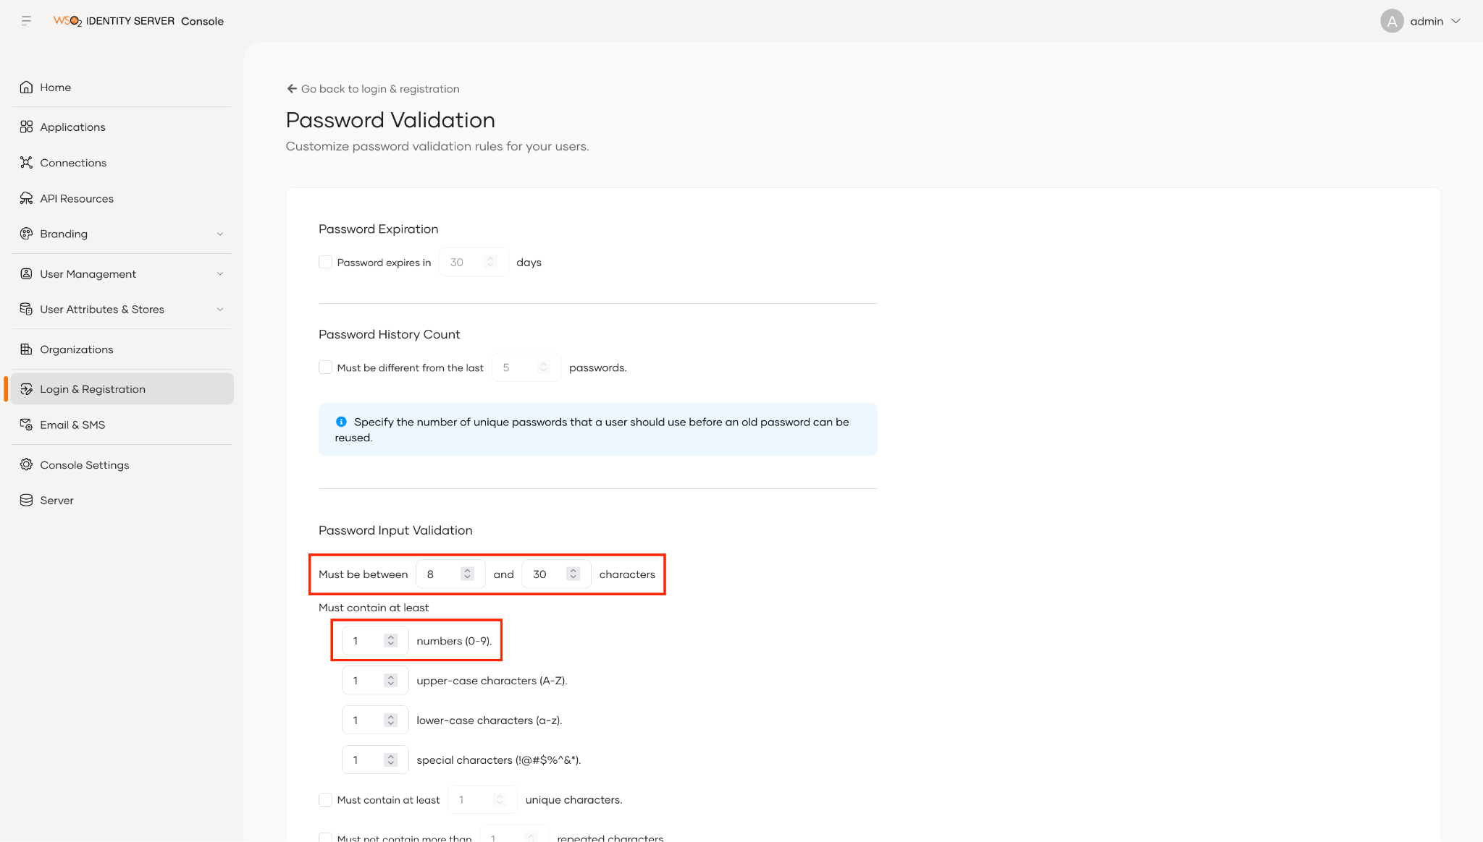
- Click Update.

Try It:
- Go to My Account.
- On the login page, click password in Forgot username or password?
- Enter the username tommy.
- Click Send Reset Link.
- An email notification is sent to the user's email address. Click on the Reset Password button given on the email.
- Type a password that breaks the policy, for example Tom@1234567. The page lists the rules and marks the ones that are not met while you type, and Continue stays disabled until all of them are met, so an invalid password cannot be submitted.
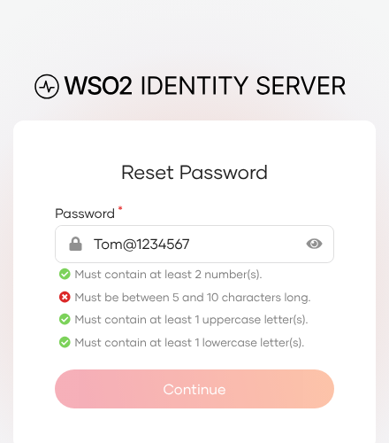

Password History

Introduction
This feature helps to prevent users from configuring passwords that were used in the recent past. For example, if you configure a count of 2 passwords, users will be prevented from reusing their last 2 passwords as the current password.

Setting up:
- In the WSO2 Identity Server Console, go to Login & Registration > Login Security > Password Validation.
- Under the Password History Count check the checkbox for the option that says Must be different from last __ passwords.
- Add 1 as the number of passwords.
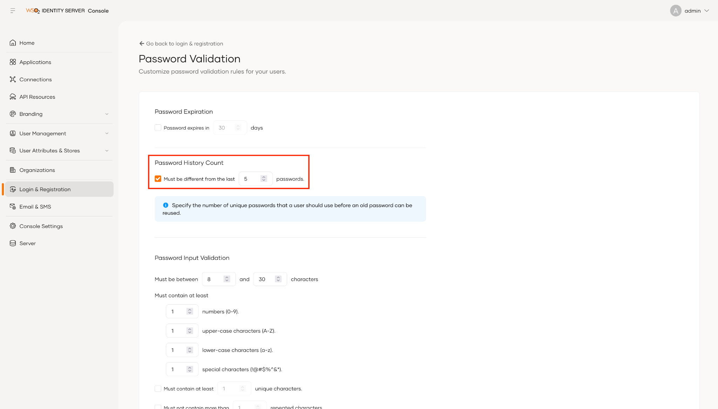
- Click Update.

Try It:
- Go to My Account.
- On the login page, click password in Forgot username or password?
- Enter the username tommy.
- Click Send Reset Link.
- An email notification is sent to the user's email address. Click on the Reset Password button given on the email.
- Enter a new password (ex: Tom@1234) and click Continue. The reset succeeds.
- Repeat steps 1–5, and this time enter Tom@1234 again. The reset is rejected with a Flow execution Unsuccessful error page because the password was used recently. (Password history only tracks passwords set after the feature is enabled, which is why the first reset is needed.)


